THE title OF THE Paper
First name LAST NAME¹, First name LAST NAME^{2,*}
- Department, Faculty, University, Address, Country, e-mail
- Department, Faculty, University, Address, Country, e-mail
* Correspondence: e-mail address
Abstract: Type the abstract here using English. Please use the Open Sans font with point size 10. Leave a space of 24 points before and 12 points after it. Use short, direct, and complete sentences. The abstract should be brief, concise and have a minimum length of 100 words and a maximum length of 200 words. It should be informative giving the scope and emphasize the main conclusions, results, or significance of the work described. (STYLE: 04__Abstract)
Keywords: Open Sans font size 10, 0 points before, 0 points after. (STYLE: 05__Keywords)

This line intentionally left blank

INTRODUCTION
(STYLE: 08__SUBTITLE 1)
The present document contains the instructions for writing the papers published in the Review of Management and Economical Engineering (RMEE). Only papers written in English are accepted. The file has been realized with the use of Microsoft Word, according to the editing instructions which will be presented as follows. For this reason you can edit your paper in two ways: either you create a new file and then you format it according to the present rules, or you use the commands copy-paste and insert the text of your paper directly into this file.
The papers sent to the RMEE’s secretariat for publishing will be edited rather in “docx” format, the RMEE’s personnel converting the Word files in “pdf” format. Before you send the article, if you can, please check the possibility of the document’s conversion.

EDITING INSTRUCTIONS
Please use for your papers only the paragraph styles included in this document:
  - 01__PAPER TITLE
  - 02__AUTHOR NAME
  - 03__ORGANIZATION
  - 04__Abstract
  - 05__Keywords
  - 06__Body Text Paper
  - 07__Bullets _1
  - 08__SUBTITLE _1
  - 09__SUBTITLE _1.1.
  - 10__SUBTITLE _1.1.1.
  - 11__TABLE TITLE
  - 12__FIGURE TITLE
  - 13__Equation
  - 14__REFERENCES TITLE
  - 15__References Body

Please:
  - Do not insert page numbers;
  - Do not modify headers and footers;
  - Do not make changes to the styles presented in this document.

Any exception from the present rules could lead to the decision of postponing the publication.

The length of the paper
Paper’s length should not exceed 6000 words (including references), although in some cases, involving mainly the reporting of qualitative data, longer versions may be accepted. Please do not change the format of the page in order to obtain the required length.
An important condition connected to the length of the paper is that the number of pages needs to be even, even if the space on the last page is not entirely used.

The general format of the paper
Please use the format A4 standard and edit your paper considering that the limits of the printing area are fixed at 4,5 cm at the upper side, 3,3 cm and the lower side, 2,25 cm left and 2,25 cm right. Except for the abstract and keywords, all the other sections of the paper need to be edited according to the format of a table with two columns. Thus, each column will have a width of 8 cm.

The title and the author of the paper
The title of the paper is on the upper side of the page, preceded by a free space of 25 points and followed by a space of 25 points. The font and size of the characters that you need to use are Open Sans 18. Use capital and bolded letters. Put the title in the center of the page and do not separate the words within it with Enter.
The information that you need to specify referring to the author of the paper is: the title, first and last name, the name of the organization to which each author belongs to. The font for the title, first and last name of the authors is Open Sans 11 (bold), while for the organization you will use Open Sans 9. The rows with the name of the organization do not need to be preceded or followed by free spaces. The information referring to the authors need to be aligned on the right side of the page.

Sections and subsections
The titles of sections and subsections will be aligned left and numbered consecutively with Arabic numbers. The section of bibliographic references will not be numbered. For the titles of the sections of the first level you will use the paragraph style called 08_SUBTITLE 1, for their subsections – 09_SUBTITLE 1.1 and so on. Thus, the titles of the sections of the first level will be written using Times New Roman 12, capital letters. They will be preceded and followed by a fee space of 12 points.
In the titles of the sections from the second level you will use Open Sans 12 with italics. These titles will be preceded by a free space of 12 points and followed by a space of 6 points.
The titles from level 3 will be written using Open Sans 11. They will be preceded by a free space of 12 points and followed by a space of 6 points. If the sections from the 3rd level need to be divided further more, then, for the titles of those subsections you will use the same style as for the third level.
If the titles of some sections or subsections are found on the first row of a column then they will not be preceded by free spaces.
The paragraphs within any section or subsection will be edited with Open Sans 11.

Tables and figures
All tables and figures need to be included in the paper’s file. They will be numbered with Arabic numbers. The title of the tables, noted above, will be written with the help of the style 11__TABLE TITLE. Please insert the tables and figures as close as possible to the place where you refer them to. (see Figure 1/Table 1). The characters used in the tables and figures are Open Sans 99.

Table 1. The title of the table
Open Sans 9

Before any table or figure, between the table and its title, as well as after the figure’s title there needs to be a space of 6 points.
The figure’s titles can be formatted with the style 12__FIGURE TITLE.
In exceptional cases, if the width of the tables or figures is bigger then the width of a column, the tables or figures can occupy the entire width of the page, with the condition that they do not exceed the limits of the printing area established by the page format.
We will not accept papers that contain obscure figures or figures that do not have all the elements grouped. That is why we ask you that, if you do the figures with the use of the graphical instruments which exist in the package Microsoft Office, to use the command Group. Place the figures in line with the text.
Figure 1. The waiting style of a network knot

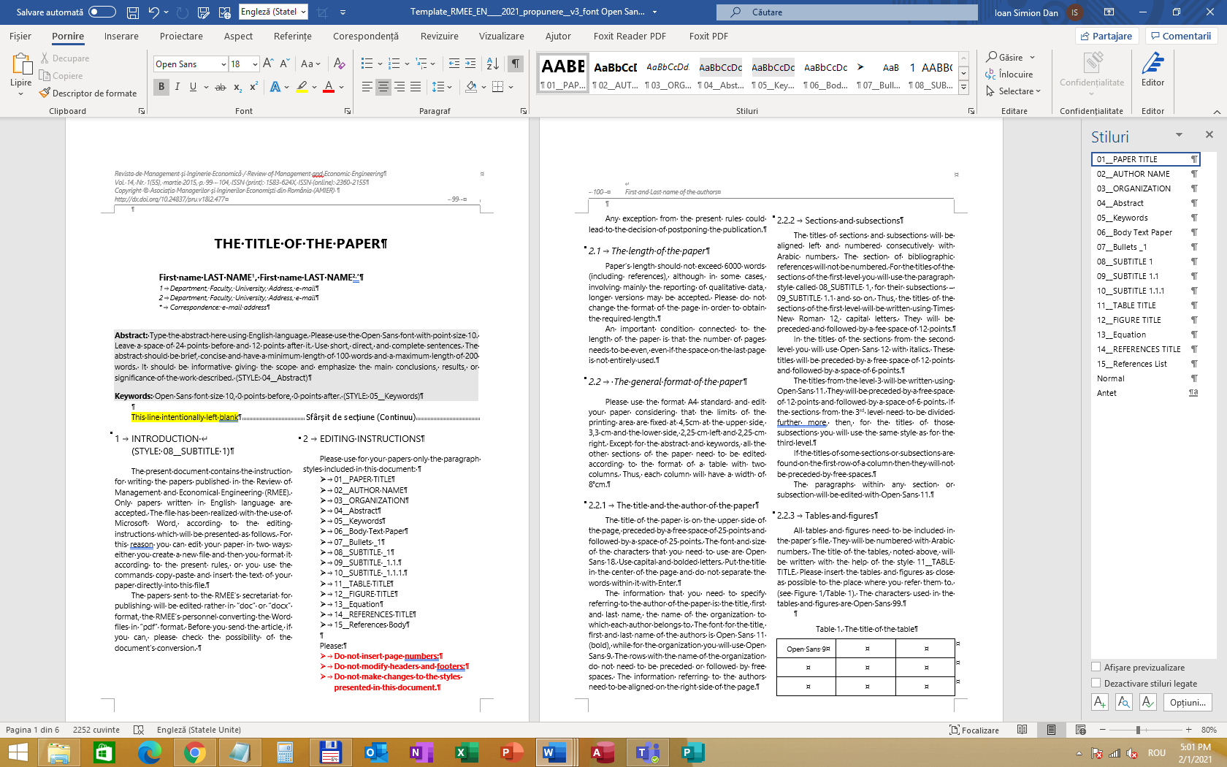
Figure 2. Formatting Styles

Formulas
The mathematical formulas need to be aligned to the center of the columns and numbered according to the following example (1). If the size of a formula exceeds the width of a column you can proceed according to the instructions presented for large tables or figures.
(1)

REFERENCES
The list of the bibliographic references as well as the way of referring to them should meet the requirements of the 6th APA Publication Manual.
Two paragraph styles have been created to facilitate the formatting of this section. The first one, 14__REFERENCES TITLE, presents the type of the characters that you need to use for the title of this section. The “15__References List” style establishes the way in which the references need to be arranged. We suggest you to firstly introduce all the references according to the APA system and then to apply the style “15__References List”. Finally use italic characters for the titles of books and magazines.
References are your entries in the alphabetical list at the end of your article or research note. This list should include all the works you have cited throughout the manuscript. The references should be formatted as follows:

Periodicals (examples)
Author, A.A, Author, B. B., & Author, C. C. (year). Title of article. Title of Periodical, xx, pp-pp. doi: xx.xxxxxxxxxx
Author, A. A., Author, B. B., Author, C. C., Author, D. D., Author, E. E., Author, F.F., … Author, Y.Y. (year). Title of article. Title of Periodical, xx, pp-pp. doi: xx.xxxxxxxxxx
Author, A.A, Author, B. B., & Author, C. C. (year). Title of article. Title of Periodical, xx, pp-pp.
Author, A.A., & Author, B.B. (in press). Title of article. Title of Periodical. Retrieved from http://cogprints.org/5780/1/ECSRAP.F07.pdf

Books
Author, A. A. (year). Title of work. Location: Publisher.
Author, A. A. (year). Title of work. Retrieved from http://www.xxxxxxx
Author, A. A. (year). Title of work. doi: xxxxx
Editor, A. A. (Ed.) (year). Title of work. Location: Publisher.

For chapters in a book or entry in a reference book (example)
Author, A.A., & Author, B.B. (year). Title of chapter or entry. In A. Editor, B. Editor, & C. Editor (Eds.), Title of book (pp. xxx-xxx). Location: Publisher.
Author, A.A, &Author, B.B. (year). Title of chapter or entry. In A. Editor & B. Editor (Eds.), Title of book (pp. xxx-xxx). Retrieved from http://www.xxxxxxx
Author, A.A., & Author, B.B. (year). Title of chapter or entry. In A. Editor, B. Editor, & C. Editor (Eds.), Title of book (pp. xxx-xxx). Location: Publisher. doi: xxxxxxxx

Meeting and symposia (examples)
Contributor, A.A., Contributor, B.B., Contributor, C.C., & Contributor, D.D. (Year, Month). Title of contribution. In E.E. Chairperson (Chair), Title of symposium. Symposium conducted at the meeting of Organization Name, Location.
Presenter, A.A. (Year, Month). Title of paper or poster. Paper or poster session presented at the meeting of Organization Name, Location.

Unpublished works (examples)
Author, A.A. (Year). Title of manuscript. Unpublished manuscript [or "Manuscript submitted for publication," or "Manuscript in preparation"].
For a detailed description of the procedure related to the citation of other types of work than those listed above, consult the 6th APA Publication Manual.
The source titles are to be given exactly as they appear in the original language.

Citation
It is important to put in the Reference section every work you have cited throughout the manuscript. The author can cite in-text as follows:

One author
Name and year: It has been found that X is associated with Y (Author, year)
Year only: Author (year) has found that

Two authors
When a work has two authors, the author should cite both names every time the reference occurs in the text.
When a work has three, four, or five authors, you should cite all authors the first time the reference occurs but in the subsequent citations, include only the surname of the first author followed by et al., (not Italicized and with a period after al.) and the year.

Two or more cited works
The author should order citations alphabetically. Designate two or more works by one author (or by an identical group of authors) published in the same year by adding “a,” “b,” and so forth, after the year.

Works with no identified author or with an Anonymus author
When a work has no identified author, the author should cite in text the first few words of the reference list entry (usually the title) and the year. Use double quotation marks around the title of an article, a chapter, or a web page and italicize the title of a periodical, a book, a brochure, or a report:
on organizational commitment (“Study Report”, 2011)
the book Motivational Outcomes (2011)

Page numbers in citations
To cite a specific part of a source, the author should indicate the page, chapter, figure, table, or equation at the appropriate point in text. Always give page numbers for quotations.
(Smith, 2011, p. 13)

Secondary sources
When the original work is out of print, unavailable through usual sources, the author should give the secondary source in the reference list and in the text you should name the original work and give a citation for the secondary source
Johnson’s report (as cited in Smith, 2011).

Final information
You can obtain additional information on the paper’s editing from the secretariat of the Review of Management and Economic Engineering:
Calea Dorobanților nr 71-73
400609 Cluj-Napoca, Romania
www.rmee.org
email: contact@rmee.org
bibliography (sample)
APA Publications and Communications Board Working Group on Journal Article Reporting Standards. (2009). Reporting standards for research in psychology: Why do we need them? What might they be? American Psychologist, 63, 839–851. doi:10.1037/0003-066X.63.9.839
Bliese, P. D. (2000). Within-group agreement, non-independence, and reliability: Implications for data aggregation and analyses. In K. J. Klein & S. W. J. Kozlowski (Eds.), Multilevel theory, research, and methods in organizations: Foundations, extensions, and new directions (pp. 349–381). San Francisco, CA: Jossey-Bass.
Chen, T., Chang, P., & Yeh, C. (2004). A study of career needs, career development programs, job satisfaction and the turnover intentions of R&D personnel. Career Development International, 9, 424–437. DOI:10.1108/13620430410544364
Eyal, O., & Roth, G. (2011). Principals' leadership and teachers' motivation: Self-determination theory analysis. Journal of Educational Administration, 49, 256-275. doi: 10.1108/09578231111129055
Griffeth, R. W., Hom, P. W., & Gaertner, S. (2000). A Meta-Analysis of Antecedents and Correlates of Employee Turnover: Update, Moderator Tests, and Research Implications for the Next Millennium. Journal of Management, 26, 463-488. DOI:10.1177/014920630002600305
Maertz, C., & Campion, M. A. (2004). Profiles in Quitting: Integrating Process and Content Turnover Theory. Academy of Management Journal, 47, 566 -582. DOI:10.5465/20159602
Managementul proceselor de productie. (2019, April 17). Retrieved from https://administrare.info/management/5179-managementul-proceselor-de-productie
Muller, K.E. & Fetterman, B.A. (2002). Regression and ANOVA: An integrated approach using SAS® Software. Cary, NC: SAS Institute Inc & John Wiley & Sons Inc.
Rosseel, Y. (2012). lavaan: An R package for structural equation modeling. Journal of Statistical Software, 48, 1-36.
Phoenix IT. (n.d.). Sistem electronic de Management al Documentelor. Retrieved from https://www.phoenix-it.ro/document-management/
Senior Software. (n.d.). Infografic: Managementul integrat al productiei, in 6 pasi. Retrieved from https://www.seniorsoftware.ro/productie/infografic-managementul-integrat-al-productiei-in-6-pasi/
Stříteský, O. (2018, October 25). How to print maps, terrains and landscapes on a 3D printer. Retrieved from https://blog.prusaprinters.org/how-to-print-maps-terrains-and-landscapes-on-a-3d-printer_29117/?utm_source=Prusa3D.com&utm_campaign=6367678606-AUTOMATION_Welcome_NEW_ENG_4&utm_medium=email&utm_term=0_4199f6d18b-6367678606-124645044
Ştefănescu, R. (2005). Conceptul de management operaţional al producţiei. Economia seria Management, Anul VIII, Nr. 1, 169-175.
Țânculescu, L. (2015) Impactul factorilor de personalitate înțeleși în cheia teoriei celor cinci mari factori de personalitate asupra angajamentului organizațional. PhD Thesis (unpublished). UBB, Cluj-Napoca.
OECD (2005) Performance-related pay policies for government employees, Paris: OECD-Publishing.

EDITING INSTRUCTIONS
Any exception from the present rules could lead to the decision of postponing the publication of your article.

